FINAL WEEK ASSIGNMENT | PRODUCT MANAGEMENT INTERNSHIP
E-Commerce Performance Evaluation & Optimization Strategy
A KPI framework, simulated performance assessment and a phased action plan for a mobile-first fashion and lifestyle marketplace (India)
Prepared by: [Your Name]
Organisation / Program: [Internship Program Name]
Date: October 2026
Important: All performance data in this document is simulated for the purpose of the exercise. The platform ("ShopSphere") is the same representative product used in the Week 4 customer journey study. Industry benchmarks are indicative ranges from public sources (see References) and should be re-verified before real-world use.

Contents

1. Executive Summary
This document sets out how ShopSphere's performance should be measured, how to read that performance under different market conditions, and which optimisations should be prioritised. It builds on the Week 4 journey map, which found that most conversion is lost to avoidable friction at checkout, product-page doubt and weak returns.
Simulated Q3 2026 baseline
- 30,00,000 sessions produced 35,400 orders: a 1.18% conversion rate, below the indicative 1.5 to 2.5% range for mobile-led Indian fashion e-commerce.
- Average order value (AOV) was Rs 1,855, giving gross merchandise value (GMV) of Rs 6.57 crore.
- After returns, fulfilment, payment fees and returns cost, each order contributed about Rs 254. Against marketing spend of Rs 100.0 lakh, the quarter's net contribution was -Rs 10.0 lakh.
- Estimated blended CAC is Rs 421 and 12-month LTV is Rs 458, an LTV:CAC ratio of 1.09, well under the commonly used 3:1 target.
What the analysis shows
- Cart abandonment is 70%. Of shoppers who start checkout, only 48.4% complete it, so checkout is the single largest leak.
- Mobile web converts at 0.62% against 1.55% in the app, despite carrying 45% of traffic. Paid social converts at 0.70%.
- 28% of orders are returned, and size/fit is the largest return reason in the simulated feedback.
Recommended strategy
Six initiatives (checkout transparency and guest login, product-page trust, speed and search, bundles, self-serve returns, and lifecycle marketing) are modelled to move quarterly net contribution from -Rs 10.0 lakh to Rs 52.5 lakh at full target (conversion 1.69%), or to Rs 18.3 lakh if only half the targeted improvement is realised (conversion 1.42%). Marketing budget is held constant in both cases. The plan is sequenced into quick wins (0 to 90 days), structural improvements (3 to 6 months) and long-term capabilities (6 to 18 months), each validated by A/B testing before full rollout.

2. Context, Objectives and Method

2.1 Product Context
ShopSphere is a mid-size online marketplace selling fashion and lifestyle products to customers across India. About 70% of traffic is mobile, acquisition relies heavily on paid social and search, and payments span UPI, cards, wallets, EMI and cash on delivery (COD). The product team's goal is profitable growth rather than traffic growth alone.

2.2 Objectives of This Assessment
- Define the KPIs that describe e-commerce health and explain how each is measured.
- Build a framework to evaluate those KPIs under different market conditions.
- Analyse simulated data to locate the largest improvement opportunities.
- Recommend process, feature and marketing optimisations with an estimated impact and a test plan.

2.3 Methodology
Step | What was done
1. Define | Created a KPI tree with one North Star metric and four driver groups, so every KPI links to profit.
2. Benchmark | Collected indicative ranges from public sources (Baymard, Google, Nielsen Norman Group, Bain, industry reports).
3. Simulate | Built a Q3 2026 baseline (sessions, funnel, channel, device, monthly trend, economics) with internally consistent numbers.
4. Diagnose | Used funnel, segment and unit-economics analysis plus simulated survey and review themes to find root causes.
5. Model | Built a driver-based model that links each initiative to a funnel or margin variable and estimates the incremental effect.
6. Plan | Prioritised actions, defined experiments with sample sizes, and set governance and alert rules.

Data note: Because no live data is available, quarterly figures were constructed to be realistic and mutually consistent (for example, orders equal sessions multiplied by conversion, summed across channels). The reasoning and formulas are what matter, and they can be reused unchanged with real analytics data.

3. KPI Framework

3.1 Structure: One North Star, Four Drivers
A long list of KPIs causes noise. This framework uses a single North Star, net contribution after marketing, because it captures both growth and profitability. Four driver groups feed it: traffic, conversion, order value and retention. Operational and customer-experience KPIs act as leading indicators behind them.
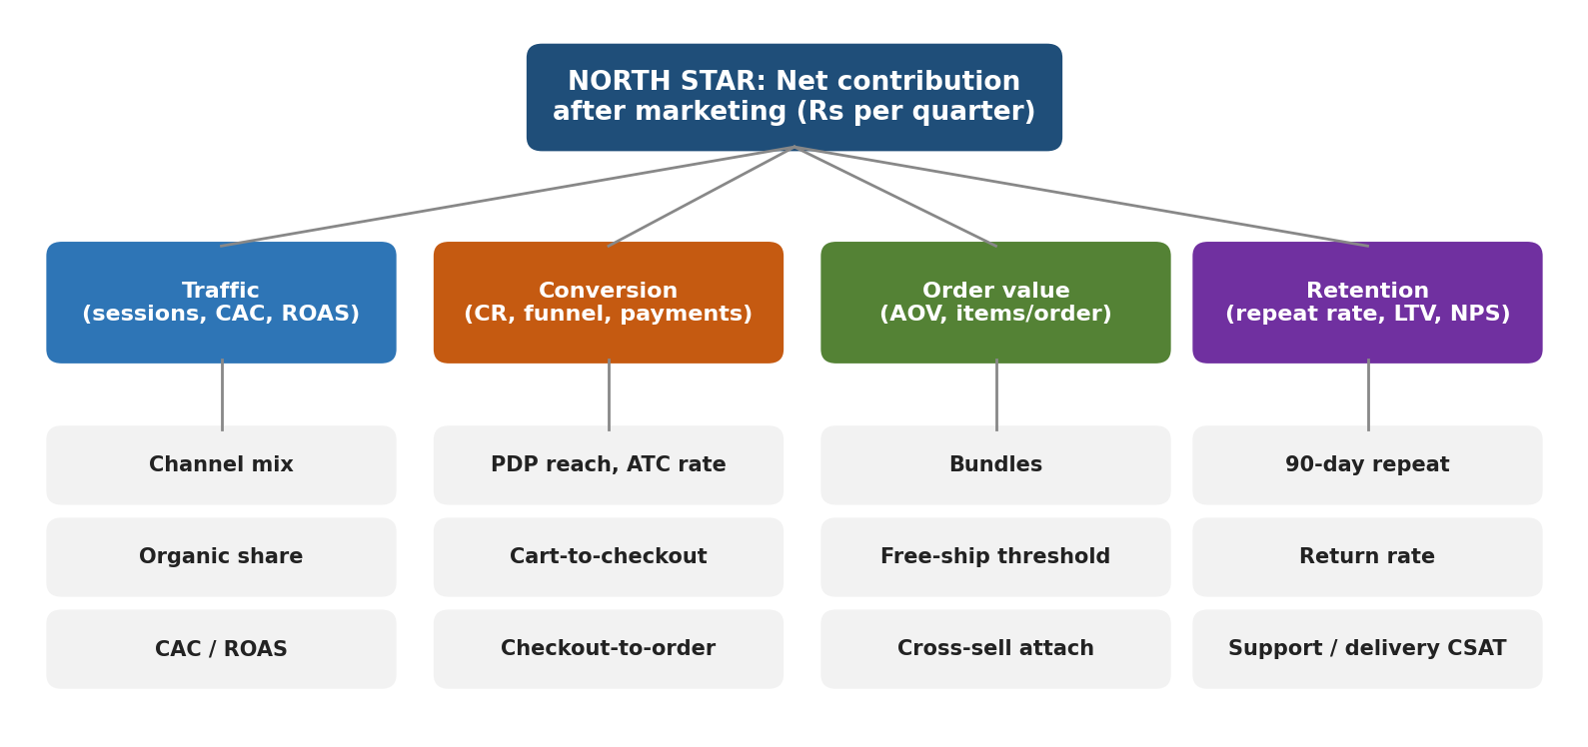
Figure 1: KPI tree linking operational metrics to the North Star
Guiding principles: (1) every KPI has a formula, an owner and a data source; (2) track both a rate and a volume; (3) segment by channel, device and new vs repeat customer; (4) pair every growth metric with a guardrail metric, for example conversion with return rate; (5) judge trends over at least a full weekly cycle.

3.2 KPI Catalogue and Measurement
A. Acquisition and traffic
KPI | Definition and formula | How it is measured | Baseline (Q3) | 90-day target
Sessions | Total visits in the period. Split by channel and device. | Web/app analytics (e.g. GA4, Mixpanel) using UTM tags and device dimension. | 30,00,000 | Growth with efficient CAC
Blended CAC | Total marketing spend / new customers acquired. | Ad platform spend plus finance data, matched to first-order flags in the order database. | Rs 421 | Rs 310
ROAS | Revenue attributed to paid channels / paid spend. | Ad platform and analytics attribution; cross-check with order data. | 6.6 | 8.0 or above
Marketing as % of GMV | Marketing spend / GMV. | Finance and order data. | 15.2% | 10% or lower
Page speed (LCP) | Largest Contentful Paint at the 75th percentile, mobile. | Real-user monitoring and Google Search Console Core Web Vitals. | 3.4 s | 2.5 s or lower

B. Conversion
KPI | Definition and formula | How it is measured | Baseline (Q3) | 90-day target
Conversion rate (CR) | Orders / sessions. | Order database divided by analytics sessions; segment by channel and device. | 1.18% | 1.5% or above
PDP reach | Sessions viewing at least one product page / sessions. Inverse of site bounce. | Funnel event tracking (view_item). | 48% | 50.5%
PDP-to-cart rate | Add-to-cart sessions / product-page sessions. | Event funnel (add_to_cart). | 8.2% | 8.9%
Cart abandonment | 1 - (orders / carts created). | Cart and order events; recovery email tracking. | 70% | 63% or lower
Checkout completion | Orders / checkouts started. | Checkout step events; drop-off by step. | 48.4% | 54%
Payment success rate | Successful payments / payment attempts. | Payment gateway dashboards, by method and bank. | 86% | 92%
Search exit rate | Searches followed by exit / total searches. | On-site search analytics (queries, zero results). | 22% | 15%

C. Revenue and order value
KPI | Definition and formula | How it is measured | Baseline (Q3) | 90-day target
AOV | GMV / orders. | Order database. | Rs 1,855 | Rs 1,929
Items per order | Units sold / orders. | Order line data. | 1.9 | 2.1
Revenue per session | GMV / sessions. Combines CR and AOV. | Order database and analytics. | Rs 22 | Rs 33
GMV | Total value of orders placed before returns. | Order database. | Rs 6.57 cr | Rs 9.77 cr

D. Retention and loyalty
KPI | Definition and formula | How it is measured | Baseline (Q3) | 90-day target
90-day repeat rate | Customers with 2 or more orders within 90 days of first order / new customers (cohort-based). | Cohort analysis in CRM or data warehouse. | 18% | 22%
Orders per customer (12 months) | Orders / unique customers over 12 months. | Order database. | 1.8 | 2.0
Customer lifetime value (LTV) | Contribution per order x expected orders over 12 months. | Cohort model; update quarterly. | Rs 458 | Rs 542
NPS | % promoters (9-10) minus % detractors (0-6). | Post-delivery survey, minimum 300 responses per quarter. | 31 | 40
CSAT | Average satisfaction score (1 to 5) after delivery or support contact. | In-app or WhatsApp survey. | 3.9 | 4.2

E. Operations and customer experience
KPI | Definition and formula | How it is measured | Baseline (Q3) | 90-day target
On-time delivery | Orders delivered by promised date / delivered orders. | Logistics partner data and tracking events. | 88% | 95%
Return rate | Returned orders / delivered orders. Split by reason. | Returns system with mandatory reason codes. | 28% | 25.5%
Refund time | Median days from return pickup to refund credit. | Payments and returns system timestamps. | 6.5 days | 2 days
Support tickets per 100 orders | Tickets raised / orders x 100, by category. | Helpdesk tool tagging. | 14 | 10

F. Unit economics (North Star group)
KPI | Definition and formula | How it is measured | Baseline (Q3) | 90-day target
Contribution per order | (1 - return rate) x gross margin x AOV - fulfilment - payment fees - returns cost. | Finance model with actuals per order. | Rs 254 | Rs 301
Net contribution after marketing | Contribution per order x orders - marketing spend. The North Star. | Finance and order data, reviewed monthly. | -Rs 10.0 lakh | Rs 52.5 lakh
LTV:CAC | LTV / CAC (12-month LTV). | Derived from the above. | 1.09 | 1.75 (3.0 long term)

3.3 Quantitative and Qualitative Measurement Methods
Method | What it tells us | How it is used here
Funnel and cohort analytics | Where users drop and how groups behave over time. | Quantifies leakage by step, channel, device and cohort.
A/B and multivariate tests | Causal effect of a change. | Validates every optimisation before full rollout.
Session recordings and heatmaps | How users actually interact with pages. | Explains checkout and product-page drop-offs.
Exit and post-purchase surveys | Stated reasons for leaving or buying. | Ranks barriers (simulated results in Section 5.4).
Usability tests (5 to 8 users per round) | Usability problems that numbers hide. | Pre-tests new flows before engineering effort.
Review and support-ticket mining | Recurring product, delivery and return issues. | Feeds fit tags, return-reason codes and policy changes.
Competitor and public data tracking | Market shifts and price pressure. | Triggers the market-condition playbook in Section 4.

4. Evaluating Performance Under Different Market Conditions
KPIs cannot be judged against one fixed number all year. Festive peaks raise traffic and basket size, slowdowns make shoppers price-sensitive, and competitor price wars lower conversion. The framework therefore compares actuals with a condition-adjusted expectation and reacts using a pre-agreed playbook.

4.1 Condition Playbook
Condition | Public signals to monitor | KPIs to watch most closely | Pre-agreed response
Normal trading | Seasonal trend in Google Trends; own 8-week moving average | CR, CAC, repeat rate, contribution | Continuous experimentation; steady marketing mix.
Festive / sale peak | Festive calendar; search-interest spikes; competitor sale announcements | Site speed and uptime, payment success, on-time delivery, return rate | Freeze risky releases; scale servers and support; protect margin with bundle offers; pre-brief logistics.
Economic slowdown | Consumer-confidence surveys; inflation and fuel-price news; falling category search interest | AOV, conversion, price-filter usage, COD share | Shift to value ranges and EMI; emphasise returns and trust; cut low-ROAS paid spend.
Competitor price war | Competitor price and offer tracking; traffic trends from public web-analytics tools | CR by channel, paid-social CAC, share of branded search | Differentiate on delivery speed, fit and service; targeted offers to loyal segments rather than site-wide discounts.
Supply or logistics disruption | Courier advisories; weather and strike alerts | On-time delivery, ticket volume, cancellation rate | Show honest delivery dates; proactive WhatsApp updates; re-route to alternate carriers.

4.2 Condition-Adjusted Targets and Alert Rules
Each KPI gets a green, amber and red band. In normal trading the bands are based on the trailing 8-week average. In a condition other than normal, the expected value is multiplied by the factor below, taken from the scenario assumptions in Section 8.3 and refreshed with actuals each quarter.
Condition | Sessions factor | Conversion factor | AOV factor | Alert rule
Normal | 1.00 | 1.00 | 1.00 | Amber if 5% below expectation for 3 days; red if 10% below.
Festive peak | 1.45 | 1.20 | 1.10 | Red if payment success below 90% for 1 hour or LCP above 3.5 s.
Economic slowdown | 0.92 | 0.90 | 0.94 | Amber if AOV falls more than 6% below trailing average.
Price war | 1.00 | 0.85 | 0.95 | Review pricing and paid mix if conversion falls 15% in 2 weeks.

Review rhythm: daily (revenue, conversion, payment success, speed), weekly (funnel, channel, experiments), monthly (North Star, unit economics, cohort retention), quarterly (strategy, benchmarks, targets).

5. Simulated Baseline Performance (Q3 2026)

5.1 Headline Scorecard
The scorecard compares simulated actuals with indicative benchmarks or internal targets. Red means well below benchmark, amber means near but below, and green means at or better than target.
KPI | Actual | Benchmark / target | Status | Comment
Conversion rate | 1.18% | 1.5 to 2.5% | Red | Mobile web and paid social drag the average.
Cart abandonment | 70% | About 70% (Baymard avg) | Amber | At the public average, but average is not good enough.
Checkout completion | 48.4% | 55% or above | Red | Late fees, forced login, long forms.
Payment success | 86% | 92% or above | Red | OTP failures and gateway timeouts.
Page speed (LCP) | 3.4 s | 2.5 s or lower | Red | Heavy images on mobile web.
AOV | Rs 1,855 | Rs 1,900 internal | Amber | Slightly under target.
90-day repeat rate | 18% | 22% | Amber | Retention messages are generic.
Return rate | 28% | Under 25% | Red | Fit and expectation gaps.
On-time delivery | 88% | 95% or above | Red | Silent delays hurt NPS.
NPS | 31 | 40 or above | Amber | Detractors cite returns and delays.
Contribution per order | Rs 254 | Rs 300 internal | Amber | Return cost is the main drag.
LTV:CAC | 1.09 | 3.0 or above | Red | Unsustainable at current CAC.

5.2 Conversion Funnel
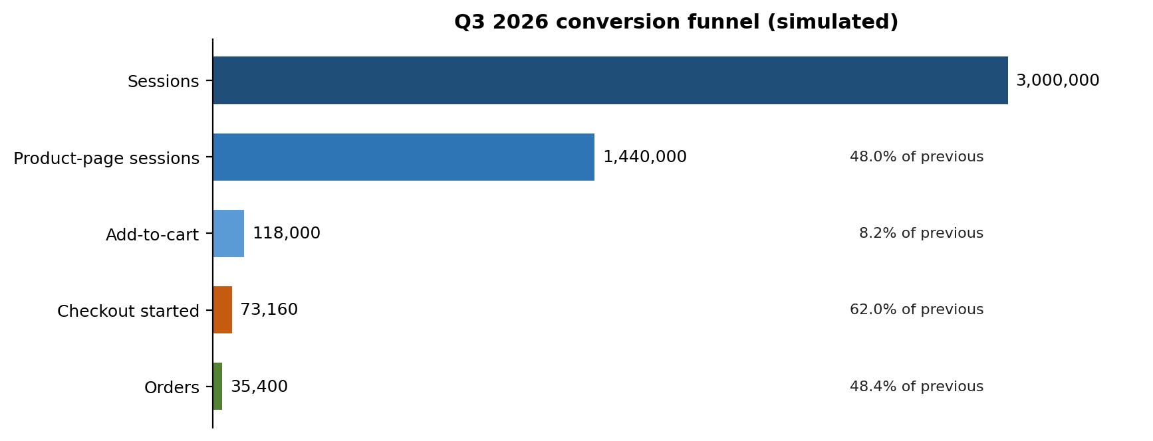
Figure 2: Q3 2026 funnel with step-to-step conversion (simulated)
Funnel step | Volume | Rate vs previous step | Calculation
Sessions | 30,00,000 | - | Analytics total
Product-page sessions | 14,40,000 | 48.0% | 14,40,000 / 30,00,000
Add-to-cart | 1,18,000 | 8.19% | 1,18,000 / 14,40,000
Checkout started | 73,160 | 62.0% | 73,160 / 1,18,000
Orders | 35,400 | 48.4% | 35,400 / 73,160

Overall: 35,400 / 30,00,000 = 1.18%. Cart-to-order is 35,400 / 1,18,000 = 30%, so cart abandonment is 70%.

5.3 Trend, Channel and Device Analysis
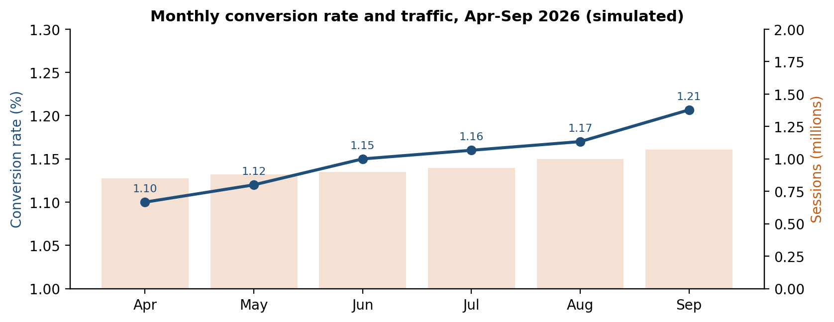
Figure 3: Conversion crept up only 0.1 points per quarter while traffic grew (simulated)
Conversion rose slowly from 1.10% in April to 1.21% in September, while sessions grew about 26%. Traffic growth is not being converted into proportional orders.
Channel | Sessions | CR | AOV | Orders | Revenue (Rs lakh) | Revenue per session
Organic search | 8,00,000 | 1.20% | 1,900 | 9,600 | 182.4 | Rs 23
Paid social | 9,50,000 | 0.70% | 1,650 | 6,650 | 109.7 | Rs 12
Paid search | 4,50,000 | 1.30% | 1,800 | 5,850 | 105.3 | Rs 23
Direct / app | 5,50,000 | 1.60% | 2,050 | 8,800 | 180.4 | Rs 33
Email / WhatsApp | 2,50,000 | 1.80% | 1,750 | 4,500 | 78.8 | Rs 32
Total | 30,00,000 | 1.18% | 1,855 | 35,400 | 656.6 | Rs 22

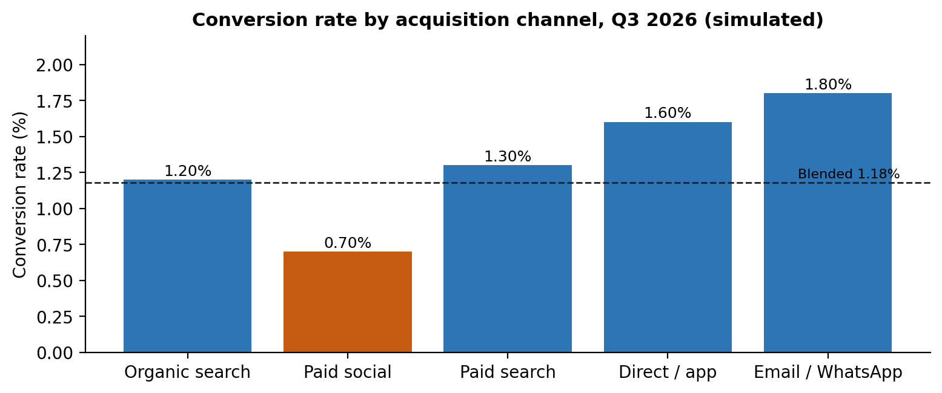
Figure 4: Channel conversion against the blended average (simulated)
Device | Sessions | CR | Orders | Share of sessions / orders
Mobile app | 12,00,000 | 1.55% | 18,600 | 40% / 53%
Mobile web | 13,50,000 | 0.62% | 8,370 | 45% / 24%
Desktop | 4,50,000 | 1.87% | 8,430 | 15% / 24%

Findings:
- Mobile web carries 45% of sessions but delivers only 24% of orders. If its conversion rose to 1.00% (still below the app), it would add about 5,130 orders per quarter, a 14% uplift.
- Paid social supplies 32% of sessions but 19% of orders, with the lowest revenue per session (Rs 12). Raising it to 1.00% adds about 2,850 orders.
- Email / WhatsApp has the best conversion (1.80%) but only 8% of traffic, so owned channels are under-used.

5.4 Qualitative Insights (Simulated Research)
The two tables below simulate typical findings from an exit survey (n = 400 visitors who left without buying) and a review of 1,000 return reasons. They are modelled on patterns reported in public research and app-store reviews, and would be replaced by real survey data.
Reason for not buying (exit survey) | Share | Linked fix
Total price higher than expected (fees, delivery) | 31% | Show total early; free-shipping threshold
Not sure about size or fit | 24% | Fit assistant, fit tags, size reviews
Unclear or slow delivery | 16% | Delivery date by pincode
Payment failed or did not trust payment page | 11% | Payment retries, UPI intent, trust badges
Other (browsing, comparing) | 18% | Wishlist and price-drop alerts

Return reason | Share | Linked fix
Size or fit issue | 41% | Fit tools, better size charts, exchange-first flow
Product looks different from photos | 24% | Photo reviews, accurate colour, video
Quality below expectation | 16% | Supplier scorecards, quality checks
Late delivery | 9% | Logistics SLAs, partner mix
Changed mind | 10% | Clear policy; nothing to fix

6. Diagnosis and Root Causes

6.1 Unit Economics Calculation
The assumptions (gross margin 35% of AOV, outbound fulfilment Rs 120 per order, payment fees 2% of AOV, reverse logistics Rs 200 per return, return rate 28%) are typical of Indian fashion e-commerce but are simulated.
Line item | Calculation | Value per order
Average order value | GMV / orders | Rs 1,855
Gross margin on kept orders | (1 - 0.28) x 0.35 x AOV | Rs 467
Less outbound fulfilment | fixed | -Rs 120
Less payment fees | 2% x AOV | -Rs 37
Less returns cost | 0.28 x Rs 200 | -Rs 56
Contribution per order |  | Rs 254

Quarter economics | Calculation
Total contribution | Rs 254 x 35,400 | Rs 90.0 lakh
Marketing spend | assumed | Rs 100.0 lakh
Net contribution after marketing |  | -Rs 10.0 lakh
New customers | 29,000 customers x (1 - 18%) | 23,780
Blended CAC | Rs 100.0 lakh / 23,780 | Rs 421
12-month LTV | Rs 254 x 1.8 orders | Rs 458
LTV:CAC | Rs 458 / Rs 421 | 1.09
ROAS (GMV basis) | Rs 656.6 lakh / Rs 100.0 lakh | 6.57

A ROAS of 6.6 looks healthy, yet the business loses money after marketing because returns, fulfilment and payment costs consume most of the margin. This is why the North Star uses contribution rather than revenue.

6.2 Root-Cause Summary
Symptom | Evidence | Probable root cause
Low checkout completion | 48.4% complete; 31% cite price surprise | Fees revealed late, forced registration, long forms, payment failures.
Low PDP-to-cart | 8.2%; 24% cite size doubt | No fit guidance, thin social proof, no delivery date.
Weak mobile web | 0.62% vs app 1.55% | Slow load (LCP 3.4 s), cramped layout, no saved login or UPI intent.
Poor paid-social returns | 0.70% CR | Ad-to-landing mismatch and cold, browsing-intent audiences.
High returns | 28%; 41% size related | Fit uncertainty and photo-versus-product gap.
Weak retention | 18% repeat; NPS 31 | Delivery silence, slow refunds, generic messaging.

7. Optimization Strategy

7.1 Initiatives by Type
Type | Initiative | Addresses | Primary KPI
Process | Total-price transparency and no late fees; faster refund SLA; return reason codes; carrier scorecards | Price surprise, slow refunds, late delivery | Checkout completion, refund time, on-time %
Process | Weekly funnel review and experiment cadence; QA for payment flows | Slow learning, payment failures | Payment success, experiment velocity
Feature | Guest checkout and phone-OTP login; short address form with autofill; payment retry and UPI intent | Forced registration, long forms, failures | Checkout completion, payment success
Feature | Fit assistant, fit tags, photo and video reviews, delivery date by pincode | Size doubt, trust, delivery uncertainty | PDP-to-cart, return rate
Feature | Self-serve returns with exchange-first option | Return cost, retention | Return rate, refund time, repeat rate
Feature | Speed programme (image optimisation, caching) and smarter search | Mobile web conversion, search exits | LCP, PDP reach, search exit
Marketing | Ad-to-landing alignment; shift paid-social budget by cost per order; retargeting for cart and wishlist | Low paid-social conversion, high CAC | Paid-social CR, CAC, ROAS
Marketing | Behaviour-triggered lifecycle messaging on WhatsApp, email and push; loyalty tiers | Weak repeat rate | 90-day repeat, LTV
Marketing | Bundles and free-shipping threshold; cross-sell | Low AOV | AOV, items per order

7.2 Action Plan: Short Term and Long Term
Horizon | Actions | Owner | Success measure
Short term  (0-90 days) | Show total price and delivery in cart; remove late fees  Launch guest checkout and phone-OTP login  Cut address form to 5 fields with pincode lookup  Add payment retry, UPI intent, trust badges  Set up abandoned-cart and back-in-stock messages  Fix top image weight issues on mobile web | Product, Engineering, CRM | Checkout completion 48% to 54%; payment success 92%
Medium term  (3-6 months) | Fit tags and photo reviews on top categories  Delivery date by pincode on product pages  Self-serve returns and refund SLA of 2 days  Bundles and free-shipping progress bar  Smarter search with typo tolerance  Re-balance paid social using cost per order | Product, Design, Ops, Marketing | PDP-to-cart 8.9%; return rate 25.5%; AOV +4%
Long term  (6-18 months) | Personalised fit assistant using purchase history  Loyalty programme with tiers and early access  Predictive models for churn and next-best offer  Carrier and warehouse network optimisation  Marketing mix model across channels  Supplier quality scorecards to reduce returns | Product, Data, Ops, Finance | Repeat rate 22%+; LTV:CAC toward 3.0

7.3 Prioritisation
Initiatives were ranked by estimated net-contribution impact (from the model in Section 8) against effort. Checkout transparency and product-page trust deliver about 63% of the modelled gain and are mostly low to medium effort, so they go first. Returns and retention programmes have smaller short-term impact but compound over time through lower costs and higher LTV.

8. Impact Simulation

8.1 Driver-Based Model
The model recomputes quarterly orders and contribution from the driver variables: orders = sessions x PDP reach x PDP-to-cart x cart-to-checkout x checkout-to-order. Contribution per order uses the formula from Section 6.1. Marketing spend and traffic are held constant to isolate the effect of product and process changes. Initiatives are applied one after another, so each increment is measured on top of the previous ones.
Driver | Baseline | Target | Initiative
Cart-to-checkout | 62% | 68% | A
Checkout-to-order | 48.4% | 54% | A
PDP-to-cart | 8.19% | 8.9% | B
Return rate | 28.0% | 25.5% | B
PDP reach | 48% | 50.5% | C
AOV | Rs 1,855 | Rs 1,929 | D (+4%)
Return cost per return | Rs 200 | Rs 170 | E
90-day repeat rate | 18% | 22% | F (+4 pp = +1,160 orders)

8.2 Results
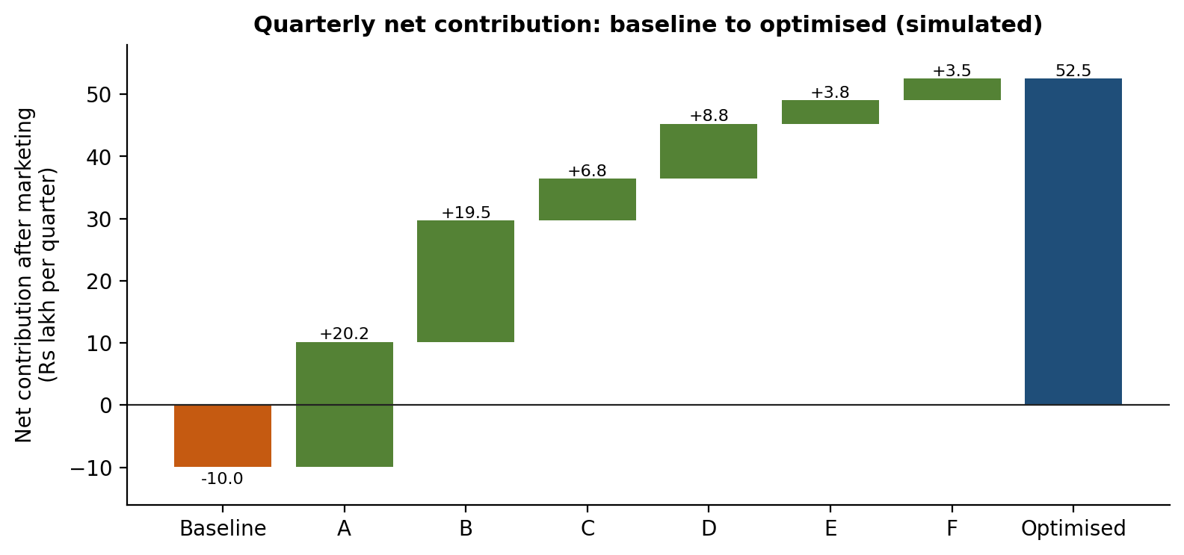
Figure 5: Incremental net contribution by initiative (A to F, see table); full-target case
Initiative (cumulative order) | Incremental (Rs lakh) | Orders after | Share of gain
A. Checkout transparency, guest & OTP login | 20.2 | 43,330 | 32%
B. Product-page trust: fit tags, photo reviews, delivery date | 19.5 | 47,060 | 31%
C. Speed and search improvements | 6.8 | 49,511 | 11%
D. Bundles and free-shipping threshold | 8.8 | 49,511 | 14%
E. Self-serve returns | 3.8 | 49,511 | 6%
F. Lifecycle & loyalty programme (+4 pp repeat rate) | 3.5 | 50,671 | 6%
Total uplift | 62.5 | 50,671 | 100%

Metric (per quarter) | Baseline | Conservative (50% of target) | Full target | Change (full)
Orders | 35,400 | 42,602 | 50,671 | +43%
Conversion rate | 1.18% | 1.42% | 1.69% | +0.51 pts
AOV | Rs 1,855 | Rs 1,892 | Rs 1,929 | +4%
GMV (Rs crore) | 6.57 | 8.06 | 9.77 | +49%
Contribution per order | Rs 254 | Rs 278 | Rs 301 | +18%
Net contribution after marketing | -Rs 10.0 lakh | Rs 18.3 lakh | Rs 52.5 lakh | +Rs 62.5 lakh
Effective CAC | Rs 421 | - | Rs 309 | -27%
LTV:CAC | 1.09 | - | 1.75 | Toward 3.0 long term

Interpretation: The full-target case is an upper bound that assumes every initiative hits its goal; the conservative case assumes half. Even the conservative case turns the quarter from a loss to a profit (Rs 18.3 lakh). Both cases leave LTV:CAC below 3.0, which confirms that longer-term work on retention, return reduction and acquisition efficiency is necessary and that short-term fixes alone will not reach the target.

8.3 Stress Test Across Market Conditions (No Optimisation)
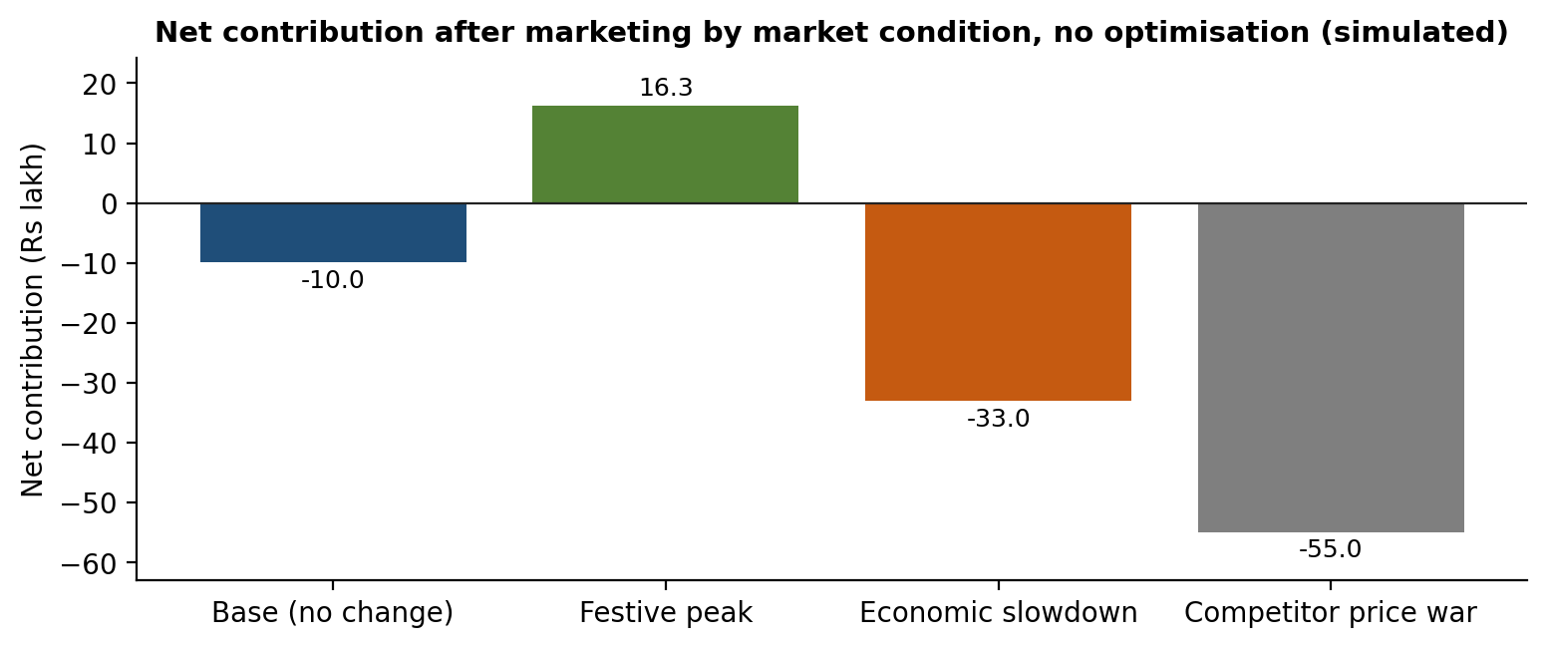
Figure 6: Net contribution under each market condition with today's product (simulated)
Condition | Sessions | Conv. | AOV | Spend | Orders | Net (Rs lakh)
Base (no change) | x1.00 | x1.00 | x1.00 | x1.00 | 35,400 | -10.0
Festive peak | x1.45 | x1.20 | x1.10 | x1.50 | 61,596 | 16.3
Economic slowdown | x0.92 | x0.90 | x0.94 | x1.00 | 29,311 | -33.0
Competitor price war | x1.00 | x0.85 | x0.95 | x1.25 | 30,090 | -55.0

Festive peak is the only condition that returns a profit under the current product, and a slowdown or price war deepens losses to roughly Rs 33 to 55 lakh per quarter. This shows the cost of leaving funnel leaks unfixed: the optimised funnel gives the business a cushion that lets it keep investing when conditions turn. The festive scenario also assumes a higher return rate of 31%, a reminder that peak seasons need extra logistics and returns capacity.

9. Experimentation, Governance and Risks

9.1 Experiment Plan
Sample sizes use the standard approximation n = 16 x p x (1 - p) / (delta squared) per variant, for 80% power and 95% confidence, where delta is the absolute change to be detected. For example, detecting a 10% relative lift in overall conversion (1.18% to 1.30%) needs about 1,33,993 sessions per variant. Every test should run for at least 14 days to cover weekly patterns, even if the sample is reached sooner.
Test | Hypothesis | Primary metric | Guardrails | Sample per variant
Total price in cart | Showing total early reduces drop-off | Cart-to-checkout | AOV, free-ship cost | About 17,925 cart sessions
Guest checkout + OTP | Removing forced sign-up lifts completion | Checkout-to-order | Fraud rate, repeat sign-ups | About 1,707 checkouts
Fit tags + photo reviews | Fit confidence lifts add-to-cart and cuts returns | PDP-to-cart | Return rate, page speed | About 17,925 PDP sessions
Mobile web speed | Faster load raises PDP reach | PDP reach, CR | Bounce, error rate | About 1,33,993 sessions
Bundles / free-ship threshold | Threshold nudges larger baskets | AOV | Conversion, margin | About 1,33,993 sessions

9.2 Governance and Dashboards
- Structure: A single dashboard with the North Star at the top, the four driver groups below, and operational KPIs as leading indicators.
- Ownership: Each KPI has one owner (for example Product for conversion, Marketing for CAC, Operations for delivery and returns).
- Cadence: Automated alerts follow the rules in Section 4.2; a weekly growth review decides which tests to ship, stop or scale.
- Data quality: Documented definitions (a KPI dictionary) so that teams use the same formulas, and quarterly review of benchmarks.

9.3 Risks and Mitigations
Risk | Impact | Mitigation
Gains smaller than modelled | Lower profit uplift | Plan around the conservative case; stage-gate investments on test results.
Guest checkout raises fraud or reduces account creation | Higher chargebacks, weaker CRM | Risk scoring, post-purchase sign-up prompt, monitor fraud as a guardrail.
Free-shipping threshold erodes margin | Lower contribution per order | Set the threshold from AOV distribution; test before rollout.
Peak-season load causes outages | Lost sales and trust | Load tests before festive season; release freeze.
Attribution errors in paid channels | Misallocated budget | Cross-check platform data with order data; run incrementality tests.
Simulated data differs from reality | Wrong priorities | Re-run the model with real data; keep formulas unchanged.

10. Conclusion
ShopSphere's simulated Q3 performance shows a business that grows traffic but loses profit after marketing, because too few visitors complete checkout, too many orders are returned and too few customers come back. Revenue-based metrics such as ROAS (6.6) hide this problem, which is why the framework anchors on net contribution.
The recommended plan is practical and sequenced. Fix checkout and product-page trust first, because they deliver about 63% of the modelled gain. Follow with speed, bundles and returns, and build retention and personalisation as long-term advantages. Test every change, track guardrails and review the KPI tree regularly, adjusting expectations to the market condition. Done well, the product moves from a Rs 10.0 lakh quarterly loss toward a Rs 18.3 lakh to Rs 52.5 lakh profit at constant marketing spend, and builds resilience for slowdowns and price wars.

Appendix A: Key Formulas
Metric | Formula
Conversion rate | Orders / sessions
Cart abandonment | 1 - orders / carts created
AOV | GMV / orders
Revenue per session | GMV / sessions = CR x AOV
Contribution per order | (1 - return rate) x gross margin % x AOV - fulfilment - payment fee % x AOV - return rate x cost per return
Net contribution | Contribution per order x orders - marketing spend
CAC | Marketing spend / new customers
LTV (12 months) | Contribution per order x orders per customer in 12 months
ROAS | GMV / marketing spend
Sample size per variant | 16 x p x (1 - p) / (absolute difference)^2
NPS | % promoters - % detractors

Appendix B: Simulation Assumptions
- Quarter: July to September 2026; 3.0 million sessions across five channels and three devices.
- Gross margin 35% of AOV; outbound fulfilment Rs 120; payment fees 2%; Rs 200 per return; return rate 28%.
- Marketing spend Rs 1.0 crore; 29,000 unique customers; 18% repeat within 90 days; 1.8 orders per customer in 12 months.
- Initiative targets are planning estimates and are tested in the experiment plan before being relied upon.

References and Public Sources
Benchmarks and methods draw on the following public sources; check the latest editions before quoting any figure.
- Baymard Institute: Cart Abandonment Rate Statistics and Checkout Usability research.
- Google / Think with Google: Mobile speed and Core Web Vitals guidance.
- Nielsen Norman Group: E-commerce UX, product page and site search research.
- Bain & Company (Reichheld): Customer retention economics and Net Promoter System.
- McKinsey & Company: Personalisation and customer-journey analytics research.
- Statista and public industry reports: Indian e-commerce conversion, returns, UPI and COD trends.
- Public experimentation guides (for example from Optimizely, VWO and Evan Miller): sample-size and A/B testing methods.
- Public app-store reviews and consumer forums: qualitative pain-point themes.

